Brighton
Buswatch

Working in partnership with Bus Users, the national charity representing bus passengers.
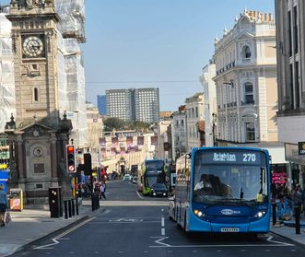

Photo courtesy of Nash Travelman

Sep / Oct 2024

End of the 701
The last day of service is 16th Nov. Introduced in May of this year, it currently runs between Brighton and Eastbourne via Falmer, Newhaven and Seaford.
Ran commercially by Stagecoach South East from their Eastbourne depot, the route has not had the monitory returns it was hoped to have despite of its regular users. It is understood to be under review for next year when changes to the route may be made.
Buswatch is keen for a route between Brighton and Newhaven via Falmer to remain in some form.
£3 fare cap announced
From the 1st Jan 2025, the £2 single fare cap is being increased by 50% to £3 as was announced by Labour leader Sir Kier Starmer two days before the budget.
Buswatch has noted that many may benefit from day ticket, currently £5.00 on the B&H bus app. which is funded though Brighton and Hove City Council’s Bus Service Improvement Plan funding.
Under the budget fuel duty was frozen, making a cut in real terms.
Valley Gardens starts January
VG3 to start in January.
Contingency plans for the period are being awaited as well as guidance for where buses will stop post development. Concern is also growing around business deliveries and how this will affect bus movements. Further discussions are being organised.
Separately, ideas are being put forward for development of Pool Valley Coach Station.
28 Increased
28 increase between Hailsham and Eastbourne.
On Sunday 22nd September Regency 28 was extended through to Eastbourne in the early mornings, evenings and on Sundays and public holidays. This provides a consistent though link via Hailsham and Lewes. This follows overwhelming feedback from bus users partly following an event in Eastbourne.
This part of the route is being taken on commercially outside of the previous hours.
Consultation day at the library
On 16th October, Brighton Buswatch sat up a table at the Jubilee library in Brighton.
With two model displays, one of buses sitting on guided bus way and another with two toy buses on a road way, a collection on key maps and timetables were available to take away.
This was a very healthy and useful opportunity to feedback. Though very positive, with a lot of praise about drivers, issues brought about included Valley Gardens, bus comfort and identification of buses in different routes.
Big Lemon reliability
Following a period of many cancellations and late running, Brighton and Hove City Council has come to the aid of The Big Lemon. Caused by supplier issues, six additional diesel vehicles have been brought to support the service - at The Big Lemons own expense.
Notably three of these buses are a shade of dark green. Funding support is provided though the Bus Service Improvement Plan funding.

RTI screens replaced
Real Time Information (RTI) screens are gradually being replaced with a new monitor type. The new screens are bright with up to seven departures include, date and time and show if the buses are being tracked in real-time.
Screens which are the previous black box type are being replaced with most of East Sussex County Council stops now complete.
Destinations announced
Destination announced
Just in time for the changes to Passenger Service Vehicle Accessibility and Information Regulations (PSVAIR) from 1st October 2024, Brighton & Hove introduced announcements both for the number and destination of the bus. This is most useful in the event if the bus being turned short of the end of the route.
This has been introduced on the newest vehicles on route 1, 1X, 2, 5, 5A, 5B, 7 and coaster routes. Older buses must be compliant by August 2026.
New timetable booklets
New timetable booklets have been produced with timetable changes on routes 22, 23, 25, 28, 29/29A, 48 and Breeze route 77, 78, & 79.
The new booklets now include a detailed map including bus stops (and names on inner-city routes) and a summery of frequency. Other route will follow as changes are made.

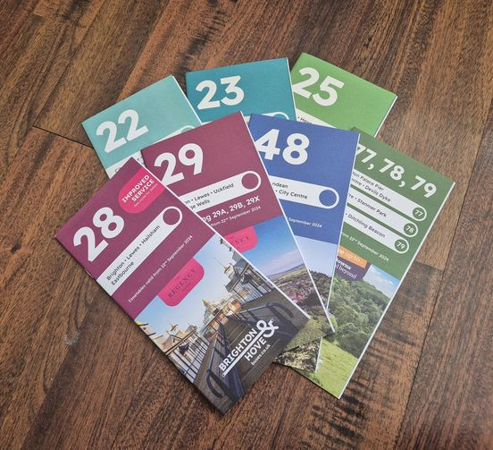

Lewes decision differed
A decision on the planning permission to replace the bus station site with 35 dwellings on in multi-storey building was made on 12th September. This was then put on hold whist further assessment is made.
Buswatch are clear in the pursuit of one, appropriate, accessible and marked point of interchange for Lewes.

Red buses
Red buses
Lewes Road has just taken three transferred Enviro400 from London. These have been converted for use on routes 23 and 25. More are expected to arrive.
It is expected that access for wheelchair users will be altered to use the front doors as per Brighton & Hover policy.
Clock tower junction almost complete
Clock Tower junction is now complete with some minor alterations expected to further help throughout of buses.
Alongside this, The bus shelters at Churchill Square have not all bee replaced with living shelters. Bus stops C & D have been merged so buses stop towards from the front stop on the westbound.
The previous Real Time Information screens are all set to be replaced here with, what is understood to be a multiple departures summery screen also available.
As routes on the coaster and coaster Local will remain using Queens Road, this leaves Imperial Arcade westbound now unused except during disruption or diversion.
Brighton Buswatch meeting
Brighton Buswatch AGM takes place on 15th January at 15.00, so please attend if you are member.
The next public meeting with Brighton & Hove City Council and bus company managers will be on: Wednesday 15th January 2025, at 16.00 in rooms 2 & 3, Brighton Town Hall. Note the change of time.
Space is limited so please e-mail Buswatch or message via Brighton Buswatch new Facebook group at the address below if you would like to attend as a guest or raise an issue.

Find us on Facebook:


Buswatch Newsletter is produced and edited by Brighton Area Buswatch. Contributions and suggestions are always welcome. E mail: brightonbuswatch@outlook.com.

